**EE447 – Experiment 5**

**Preliminary Report**

Q1)

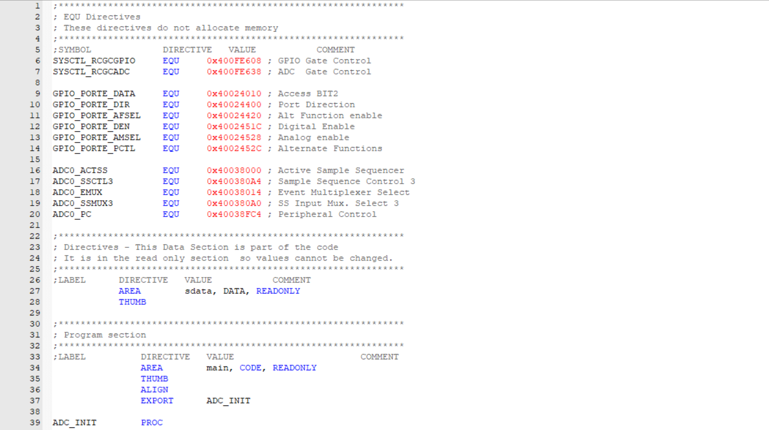 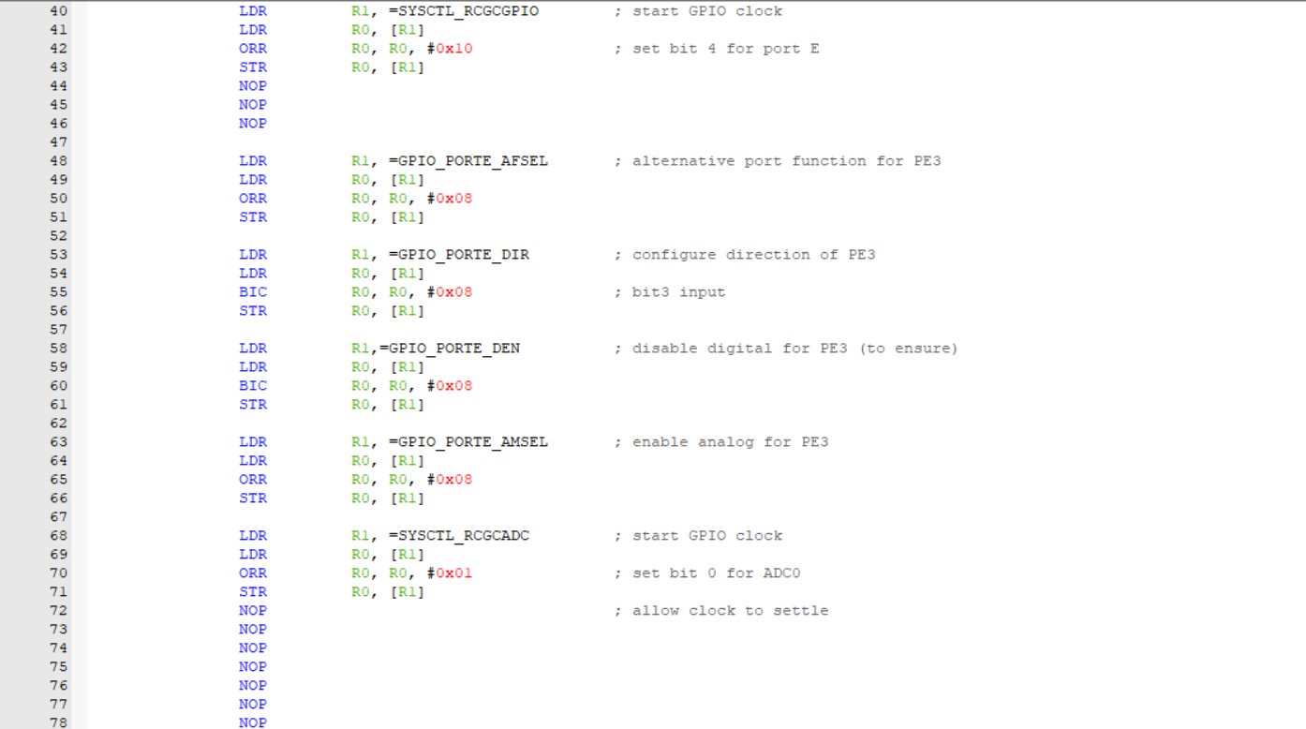

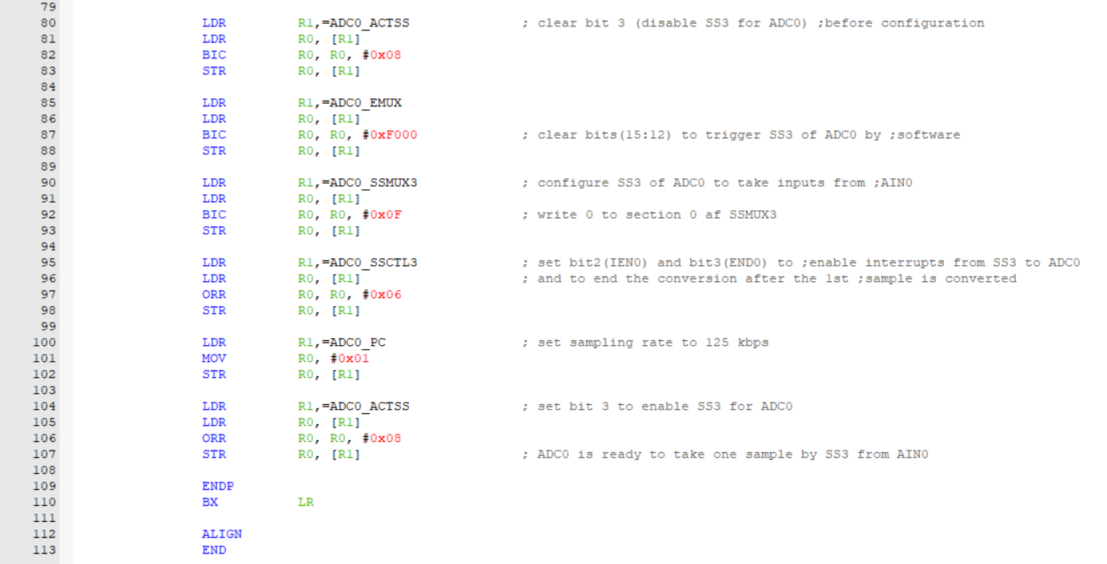

Figure 1: ADC initialize subroutine code (ADC_INIT)

I have written all three parts of this preliminary work in a same main file for simplicity. Due to that reason, I will add the code as whole and highlighted the blocks of code relevant to the parts given in preliminary work.

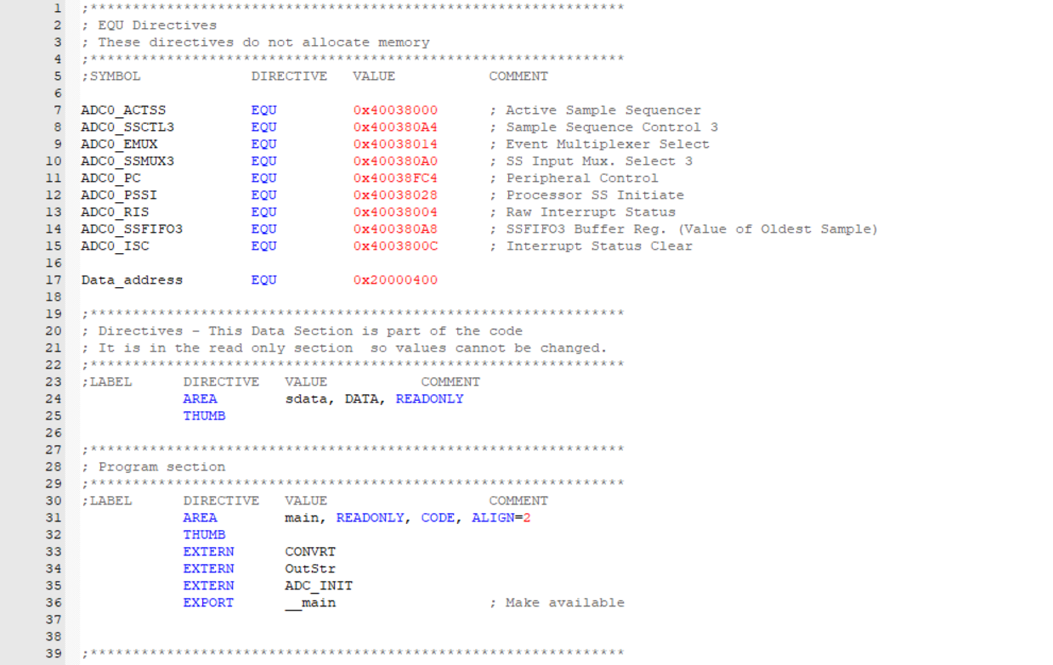

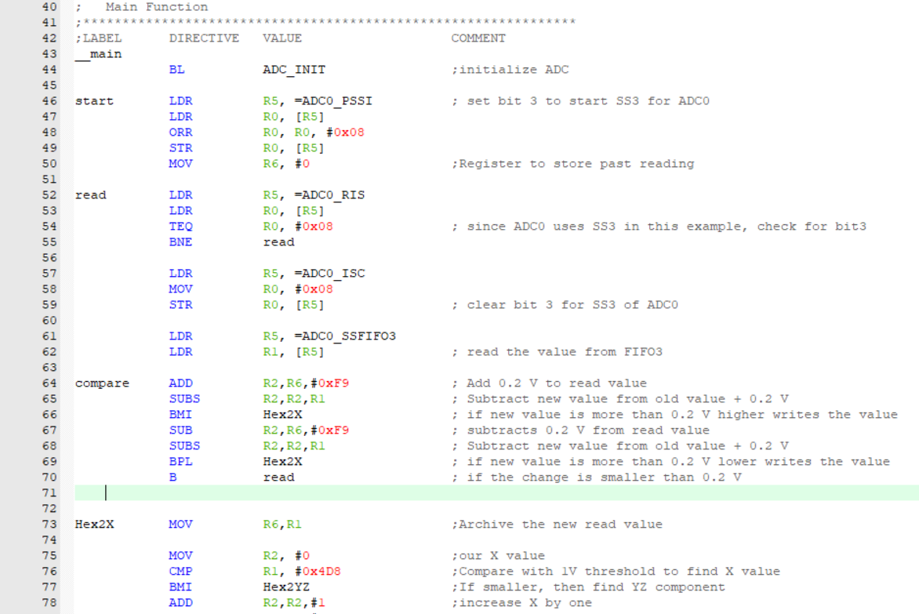 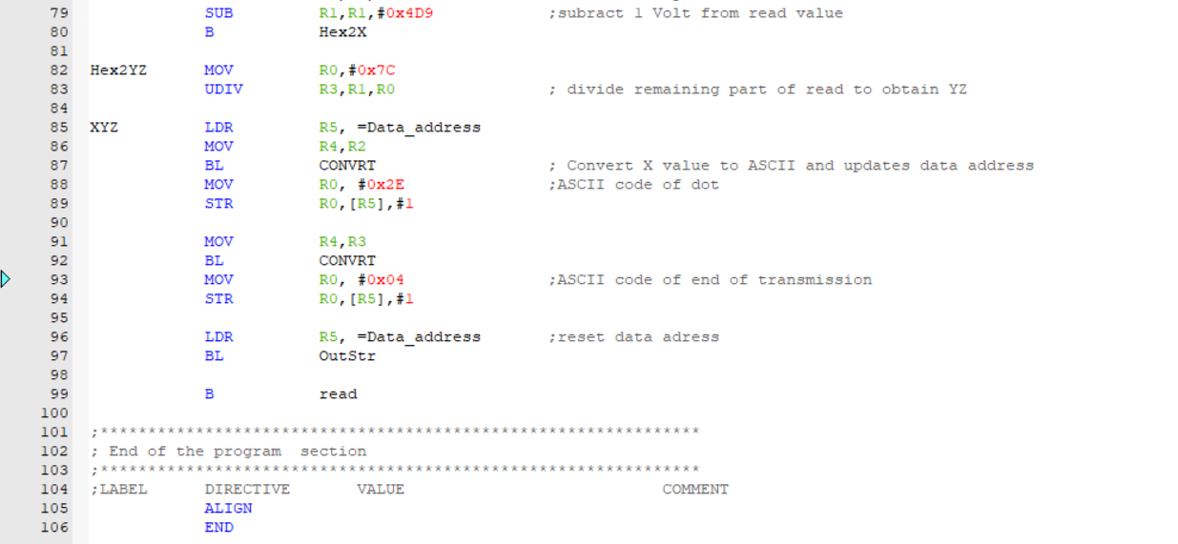

**Q3**

**Q3**

**Q2**

**Q1**

Figure 2: The main code